# submission

 My Files  My Files  University

Document Details

Submission ID trn:oid:::3618:89463825

6 Pages

3,116 Words

19,031 Characters

Submission Date

Apr 3, 2025, 9:17 PM GMT+5:30

Download Date

Apr 3, 2025, 9:17 PM GMT+5:30

File Name final.docx

File Size

339.2 KB

# 12% Overall Similarity

The combined total of all matches, including overlapping sources, for each database.

Filtered from the Report

Bibliography Quoted Text

Match Groups

 31 Not Cited or Quoted 12%

Matches with neither in-text citation nor quotation marks

0 Missing Quotations 0%



Matches that are still very similar to source material

0 Missing Citation 0%



Matches that have quotation marks, but no in-text citation

0 Cited and Quoted 0%



Matches with in-text citation present, but no quotation marks

Top Sources

|  |  |
| --- | --- |
| 1% | Internet sources |
| 2% | Publications |
| 10% | Submitted works (Student Papers) |

Integrity Flags

0 Integrity Flags for Review

Our system's algorithms look deeply at a document for any inconsistencies that would set it apart from a normal submission. If we notice something strange, we flag it for you to review.

A Flag is not necessarily an indicator of a problem. However, we'd recommend you focus your attention there for further review.

No suspicious text manipulations found.

Match Groups

 31 Not Cited or Quoted 12%

Matches with neither in-text citation nor quotation marks

0 Missing Quotations 0%



Matches that are still very similar to source material

0 Missing Citation 0%



Matches that have quotation marks, but no in-text citation

0 Cited and Quoted 0%



Matches with in-text citation present, but no quotation marks

Top Sources

|  |  |
| --- | --- |
| 1% | Internet sources |
| 2% | Publications |
| 10% | Submitted works (Student Papers) |

Top Sources

The sources with the highest number of matches within the submission. Overlapping sources will not be displayed.

1

Submitted works

VIT University on 2024-10-09 10%

2

Internet

[www.arxiv-vanity.com](https://www.arxiv-vanity.com/papers/2205.13522/) <1%

3

Submitted works

Cranfield University on 2024-09-01 <1%

4

Internet

[www.medrxiv.org](https://www.medrxiv.org/content/10.1101/2022.12.19.22283665v1.full.pdf) <1%

5

Publication

[Lijia Xu, Yanjun Chen, Ao Feng, Xiaoshi Shi et al. "Study on detection method of m…](https://doi.org/10.1016/j.envres.2023.116389) <1%

6

Publication

[Mohamed Fadhlallah Guerri, Cosimo Distante, Paolo Spagnolo, Fares Bougourzi, …](https://doi.org/10.1016/j.ophoto.2024.100062) <1%

7

Internet

[dokumen.pub](https://dokumen.pub/question-answering-over-text-and-knowledge-base-9783031165511-9783031165528.html) <1%

8

Publication

[Julia N. Möller, Martin G. J. Löder, Christian Laforsch. "Finding Microplastics in Soil…](https://doi.org/10.1021/acs.est.9b04618) <1%



***Abstract*—**Microplastics are alarming environmental contaminants and threaten serious harm and remediation of the environment. However, traditional detection methods are typically laborious and expensive, and do not accommodate the precision required for surveying environmental complexities. This study offers a full deep learning solution to the detection of microplastics to enhance the efficiency and accuracy of real- world applications for practical implementation. This model is of training of a

a convolutional neural network model and

Transformer neural network model



**1**

on a large-volume diverse image and spectral data set, detecting microplastics under a range of conditions. Additionally, the optimized model can be easily deployed even to a low-resource setting and used under quite different field conditions without heavy computational resource. The system is scalable for microplastics detection and facilitates an increase in the speed, accuracy. It is noteworthy that the study provides not only seminal solutions in the context of microplastics pollution in for sustainable pollution control and ecosystem conservation but also gigantic acres of challenges.

***Index- CNN AND TNN* MODEL, DEEP LEARNING, DETECTION**



**8**

I. INTRODUCTION

Microplastics(MPs), refer to polymer spheres that have diameters smaller than 5 mm and have pervaded almost all kinds of environmental niches-ranging from lakes, oceans, soils, and air to food sources. Emerging as an environmental threat, these particles pose serious risks to ecosystems and human life. The forever nature of microplastics within the ecosystem has become more of a global concern because they result from diverse sources like plastic waste, man- made textiles, personal care items, and industrial processes. As far as plastic pollution research is concerned, for more than a decade, it has been solely focused on marine and freshwater ecosystems. Only recently have investigations of microplastics in terrestrial environments garnered much- needed attention.

Toxins, physical trauma, and death in some instances are conditions aid in the survival of microplastics from marine organism ingestion in aquatic ecosystems. The main worry is the accumulation of microplastics with other toxic chemicals, including heavy metals, herbicides, pathogens, and persistent organic pollutants (POPs), all resulting in their transportation across ecosystems. Microplastics in soils may alter structure, interrupt nutrient flow, decrease water holding, and suppress plant growth. Along the way, they also impact soil life and thus biodiversity, which, in turn, can impact the long-term operation of ecosystems' productivity.

Microplastics in soils is threat to soil pollution and agricultural settings because the health of the soil is fundamental in food production. Interactions of microplastics with other soil contaminants and the behavior of contaminants in soil ecosystems are vital to truly assess risks to environmental and human health. Because of their size and surface properties, microplastics are vectors for heavy metals, polycyclic, thus transferring them from one ecosystem to another. Pollutant- loaded microplastics and also

find their way into the food chain

inflict injury on wildlife and human beings through polluted water and crops.

This study is based on CNN and TNN to perform enhanced detection of microplastics in water and soil. Pollutant microplastics can find their way to food chain and reflect on wildlife and human beings thorugh water and crops. This model is on the framework of deep learning hyperspectral imaging and CNN and TNN altogether.

This research particularly benefits from hyperspectral imaging (HSI), which measures signal intensity across many wavelengths to identify microplastic particles with high precision using a specific spectral signature for each one. The combination of HSI, Back Propagation, and One- Dimensional Neural leads to improved accuracy in microplastic detection. Each of the approaches offers special advantages: optimal hyperplane SVM separation, flexibility of adaption to a dataset by BPNN, and efficient computation using spectral data by 1D-CNN.

Two deep learning models are implemented in this system - MobileNetV2 based CNN and TNN. This CNN model makes MobileNetV2 a good candidate because it is efficient and capable of capturing complex features in image data. In addition, Grad-CAM and SHAP methods ensure model interpretability for an understanding the detection of microplastics.



**1**

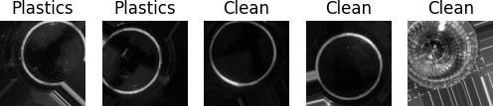techniques for classifying various types of microplastics through



**1**

hyperplane

classification and prediction of new image samples



**1**

forward networks harnessed with self-attention mechanisms to learn data patterns, which provide a different approach than imaging analysis. The TNN will have great strength since it can manage heterogeneous datasets and is compatible with Py-Torch, making it very useful for the identification of microplastics in samples.

Fig. 1. Image dataset

II. EXISTING SYSTEM



**1**

**1**

**1**

an advanced

**A. Hyperspectral Imaging**

Hyperspectral Imaging (HSI) is

technology that

microplastic detection, multiple

acquires in an extended electromagnetic spectrum spectral range employed in the study was from 900 nm to 1700 nm, which allows the detection of unique characteristics of microplastics.

images

range of

wavelengths. The

## B. Pretext Task for Coarse-Learning

a) Support Vector Machine**:**

A problem is then optimized to find the parameters of that hyperplane which gives the maximum distance of the training samples known as support vectors moreover this vectors are utilized to determine the hyperplane. SVM learns by classifying the image samples into two classes and thus intentionally classifies newer entries

based on their position

relative to

hyperplane. Samples on one side of the



**1**

where it has been proven to be extremely efficient in high- dimensional hyperspectral data. In addition, SVM's versatility to accommodate classification as well as regression tasks is made possible by the availability of a large number of kernel functions .

However, the drawbacks attached to SVM application in hyperspectral imaging and microplastic detection are numerous. One may enumerate as some of them the high computational cost attached to SVMs, especially at the stage of training, as one of the biggest drawbacks for their use in large datasets. The resource-hungry training process may even limit its field in actual implementation.

tuning SVM parameters

the regularization parameter

(C) and kernel parameters requires

careful optimization to

Also,

like

very

However, all drawbacks are eclipsed by the good performance of the SVM model in image classification and

achieve the best performance.

these

accurate

classification of image samples

an

precise

the model's

and

in

applications, including environmental monitoring and

microplastic detection.

|  |  |  |
| --- | --- | --- |
| hyperspectral imaging as far as achieving an  via construction of optimal | | |
|  | supported by maximized margins. A | |
| is possible,  which shows effectiveness versatility | | |
| varying | |  |

layers can learn complex.

ability especially useful applications like

BPNN provide significant

b)

flexibility and versatility

that

classified into

hyperplane are

one class,

those on the

Back Propagation Network*:*

between input and output variables.

This

is

for

and

other classified into class. This method is highly effective for image classification since it has the ability to generalize and process data of high dimensions. It has proven to induce ordinary accuracy field. specifically used such and therefore is more favorable for hyperspectral image (HSI). In HSI, the margin maximization property in which SVM avoids overfittiPnaggei5somf 9a- dInetegitrsityuStumbmoissstiosntrength. SVM proves to be very effective, for instance, in microplastic detection

side are

the other

in this

SVM is

in

high-dimensional spaces



**1**

Submission ID trn:oid:::3618:89463825

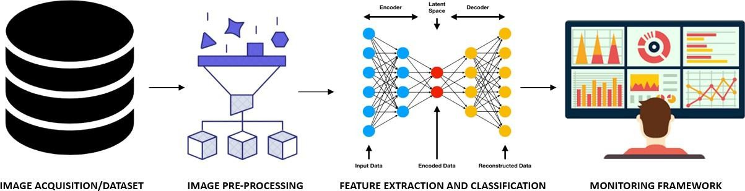

Fig. 2. Framework

desires the model to be able to generalize not just in time series forecasting but also in multiple application domains. The incremental learning property afforded by the iterative weight updating of BPNNs is one major advantage over other models. Though, they are more prone to overfitting as the training data is less and with insufficient regularization. The training procedure takes longer, is very compute-intensive, and sometimes requires supercomputers

for deep networks or large

**1**

problem that they might get stuck at a local minimum during optimization, and this suboptimal performance would result.



**5**

datasets. Another

with BPNNs is

One-Dimensional Convolutional Neural Network*:*

The

of convolutional

shared weight feature layers helps reduce the number of parameters, while improving computational efficiency. like

benefit much from the one-dimensional representation using 1D-CNNs. 1D-CNN can effectively capture local patterns but typically codes learning of data features through training before modeling output classification. It adds to the computational load as the model is usually built on a large scale and thus requires a considerable amount of computational power. Constructing the architecture involves very simple issues, including the number of layers, filters.. Nonetheless, this study thus puts up that the model exhibited the best classification performance, indicating its appropriateness for microplastic detection in water and soil.

One-dimensional data

time-series or spectral

data



**1**

## C. Deep Learning-based methods

The method starts with obtaining through

high-resolution images of

microplastics

optical, electron , and spectroscopy



**1**

On acquiring the images, they are subjected to useful preprocessing to augment quality and reduce noise. Works on the identified important properties of microplastics, which could be those related to shape, size, and texture. The CNNs are able to discriminate microplastics from various other materials with high accuracy based on that.

Classification then proceeds utilizing models such as CNNs,

GANs to

the microplastic particles. These

models are

trained on

datasets and

real-world data,

them

reliable

RNNs, and identify

thoroughly massive

using identify

which makes in all

checked

more to

The embedding of the deep learning process within a holistic monitoring framework allows for comprehensive data storage, analysis, and visualization.

microplastics

environments.

III. DATASET

The model was compiled employing the categorical loss function as well as the Adam optimizer. The training process observed training and validation accuracies and corresponding losses. An early stopping mechanism was incorporated into the use case to avoid overfitting, halting the training process upon the occurrence of an increase in validation loss.

microscopy.



**1**

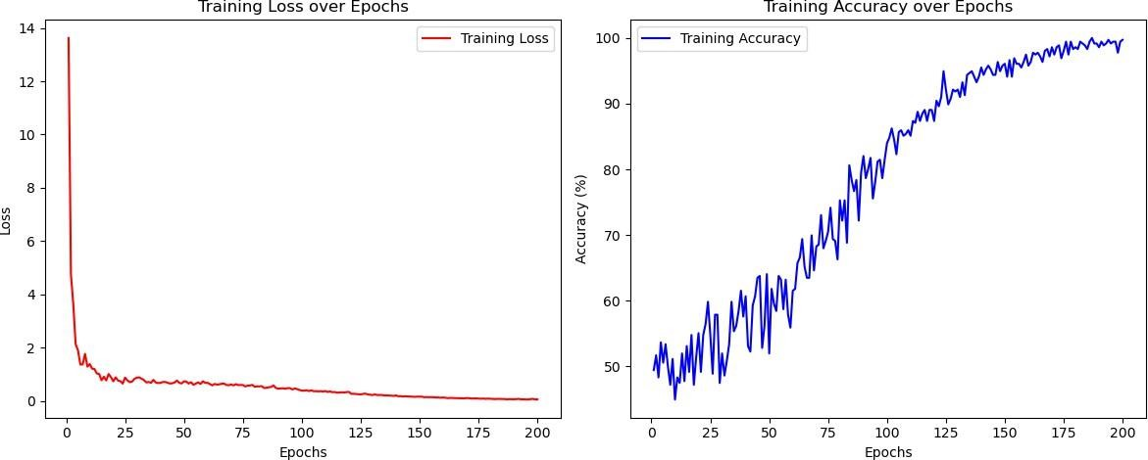

TNN

1. This microplastics contains a total divided into with procedure being run on all images to ensure the images remain in a consistent orientation for analysis. Static cropping was performed horizontally on the image between 30-85% and vertically on the image between 15-85%. At that point, there were changes in the classes-no remapping was done though, three classes from the dataset were dropped. To prevent any further data dilution, a filter was used to drop any images with no annotation present, and only annotated images went through to the next stage.

Fig. 3. Training & Validation accuracy values using

dataset for computer vision

of 1362 images

2 classes,



**1**



**3**



**4**

1. The NOAA ICOADS data comprises weather and marine data from every corner of the Earth on ships of different kinds, commercial freighters, navy vessels, research vessels, and buoys. Each entry provides considerable distinctive information on the weather or ocean conditions experienced at that time. Each entry boasts of the exact coordinates of the observation, which is especially good for visualization. The data goes far back in history-of records stretching even back to the year 1662!

IV. PROPOSED SYSTEM

## CNN via MobileNetV2

Microplastics were detected and classified in soil and water samples using a MobileNetV2-based Convolutional Neural Network (CNN). MobileNetV2 was chosen for its efficient feature extraction capabilities, making it deployable in low- resource settings.

**1**

**1**

* 1. Data Preprocessing: The dataset comprised JPG images that were preprocessed for regularization and compatibility with the CNN architecture. Each image was resized to specified dimensions of 128×128 pixels to maximize computational efficiency. Images were loaded in grayscale to save memory; however, processing was done using three channels to fit the input requirements of the MobileNetV2.



**1**

Image augmentation was performed via the Image-Data- Generator function allowing for variations in the training dataset and thereby promoting the generalization capacity of the model. partitioned with

rescaling images being imposed in order to compensate for variations in orientation.

The dataset was

into training and validation sets,

of

* 1. Model Architecture: The MobileNetV2 architecture was applied with frozen convolutional layers, preserving previously learned features. A custom classification layer was introduced for adapting the model for microplastic detection, with

fully

after

connected layers

followed

softmax activation

function

the output.

being

for

* 1. Training Procedure: The model was compiled employing the categorical loss function as well as the Adam optimizer. The training process observed training and validation accuracies and corresponding losses. An early stopping mechanism was incorporated into the use case to avoid overfitting, halting the training process upon the occurrence of an increase in validation loss.
  2. Evaluation: Post the training period, the model was informally evaluated on a separate test dataset. Predictions made were compared against the true labels, and confusion matrices and a classification report were employed to convey performance evaluation. The criteria for measurement included accuracy, precision, recall, and F1-score.
  3. Fine-tuning: Different activation functions were tried to improve the model performance, and their results were recorded for comparison. The fine-tuning process comprised training iterations with different activation functions, and results were illustrated with plots

accuracy and loss

for both

was

training and validation

The

model

saved in

final

datasets.

TF

H5 and

formats for future use.

## TNN

It was developed for the classification of

microplastic types in

ground- water Transformer architecture

soil and

samples. The



**1**

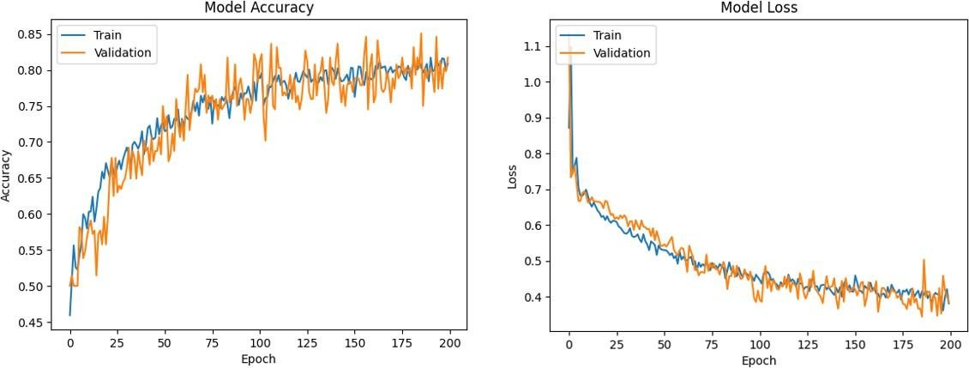

CNN with MobileNetV2

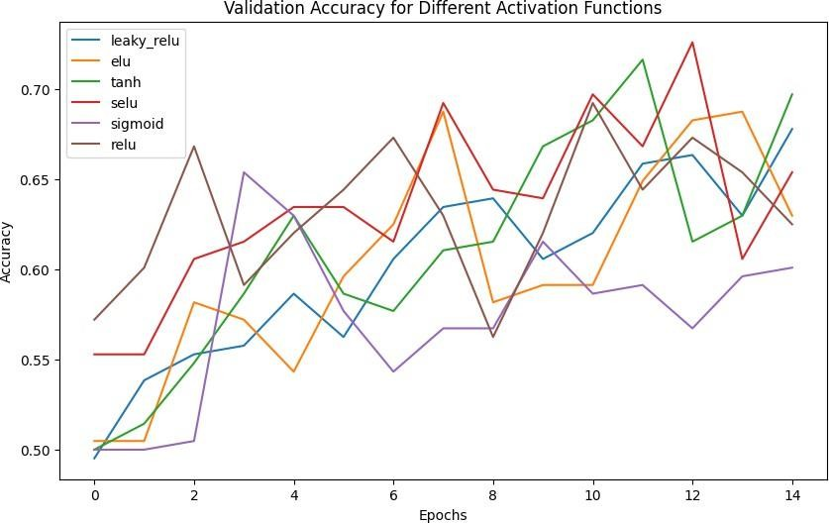utilizing cross-entropy to formulate the loss function used in multi-class classification. The model was then subjected to evaluation after each epoch with both validation and test sets to check for effective learning.

Fig. 4. Training & Validation accuracy values using

4) Evaluation: This supervised model was observantly monitored on the accuracy and loss metrics and had its final evaluation on the test dataset. Accuracy,

precision, recall, and



**7**

were in process to comprehensively measure such performance in terms of classification ability.

F1 metrics

used

the evaluation

TABLE

Comparison of accuracies



**1**

ON

Fig. 5. Validation Accuracy for Functions

MODELS

**Model**

***Validation Accuracy %***

***Standard Accuracy %***

***Classifier***

HSI

CNN

MnV2

Py- former(pyf)

94%

81.73%

90%

84%

82.06%

85.51%

**1**

**1**

its ability it effective

Svm

to process sequential data, making

for



**6**

analyzing and spectral data.

time-series

* 1. Data Preprocessing: The Transformer model was implemented in Py-Torch with a custom dataset loader, which transformed the dataset into tensors and converted feature-label pairs to Py-Torch's Data Loader for efficient processing. The



**1**

The current

new way of

TNN

V. CONCLUSION

a

detecting and

presents

using a mixture

quantifying microplastics in soil and water

of

preprocessing steps included reshaping, differentiation with respect to order, and conversion of string labels to numeric representations. The data was then shuffled and loaded into balanced batches to facilitate robust training.

research

* 1. Model Architecture: The Transformer architecture comprised with

multi-head self-attention

position-wise feed-



**2**

layer normalization, all which were arranged layers in encoder module. It was enhanced further by positional encoding so that it could understand the sequential data, which was important in microplastic sample pattern detection.

forward networks and

of

in

the

* 1. Training procedure: The model was trained by using a script which specifies the important parameters like

batch size,



**1**

Ada-grad optimizer was

learning rate, and number of epochs.

used.

CNN and TNN methodologies. The use of Deep Learning

algorithms augmented with Hyperspectral imaging (HSI) in this research promises to add a significant level of improvement in precision, efficacy, as well as scalability to environmental monitoring systems. The proposed approach addresses critical issues in microplastic detection, especially the limitations of traditional techniques working in field environments. It is also designed for use in low-resource settings. This combination of a Transformer Architecture and CNN based on MobileNetV2 enables a powerful, multifaceted strategy that integrates image- based and sequential data processing techniques. While the TNN model provided further strength in handling sequential data, such as spectral measurements, the CNN model optimized for microplastic classification proved excellent in distinguishing microplastics.

The models have shown promising results with respect to accuracy and utility after exhaustive evaluation. While the present deep learning-based system has many resourceful aspects, there still remain bottlenecks related to data quality, processing requirements, and realism in real-time monitoring. Future investigations can focus on integrating Internet of Things (IoT) sensors for the purposes of a continuous monitoring process, increasing the dataset, and improving model interpretability. This study, as such, offers a scalable, efficient, and workable alternative solution to environmental monitoring and ecosystem preservation, thus representing a major step toward the fight against global microplastic pollution.

1. Xu, Jiongji, and Zhaoli Wang. “Efficient and Accurate Microplastics Identification and Segmentation in Urban Waters Using Convolutional Neural Networks.” The Science of the Total Environment, vol. 911, 1 Feb. 2024, pp. 168696–168696, https://doi.org/10.1016/j.scitotenv.2023.

168696. Accessed 10 Sept. 2024.

1. Dataset [https://www.kaggle.com/datasets/imtkaggleteam/](http://www.kaggle.com/datasets/imtkaggleteam/) microplastic-dataset-for-computer-vision https://data-explorer.oecd. org/vis?tenant=archive&df[ds]=DisseminateArchiveDMZ&df[id]=DF PLASTIC WASTE 5&df[ag]=OECD

References

* 1. Chen, Y., Wen, D., Pei, J., Fei, Y., Ouyang, D., Zhang, H., & Luo, Y. (2020). Identification and quantification of microplastics using Fourier- transform infrared spectroscopy: Current status and future prospects. Current Opinion in Environmental Science & Health, 18, 14–19. https:

//doi.org/10.1016/j.coesh.2020.05.004

* 1. Malyuskin, O. (2020). Microplastic detection in soil and water using resonance Microwave Spectroscopy: A Feasibility study. IEEE Sen- sors Journal, 20(24), 14817–14826. https://doi.org/10.1109/jsen.2020.

3011311

* 1. Xu, L., Chen, Y., Feng, A., Shi, X., Feng, Y., Yang, Y., Wang, Y.,

Wu, Z., Zou, Z., Ma, W., He, Y., Yang, N., Feng, J., & Zhao, Y. (2023). Study on detection method of microplastics in farmland soil based on hyperspectral imaging technology. Environmental Research, 232, 116389. https://doi.org/10.1016/j.envres.2023.116389

* 1. Zhang, L., Wei, W., & Huang, G. (2024). Research on Soil Microplas- tics Detection Algorithm based on Hyperspectral Imaging Technology.

Deleted Journal, 1(1), 11–15. https://doi.org/10.54097/ozoub74p

* 1. Han, X., Jiang, N., Hata, T., Choi, J., Du, Y., & Wang, Y. (2023). Deep learning based approach for automated characterization of large marine microplastic particles. Marine Environmental Research, 183, 105829. https://doi.org/10.1016/j.marenvres.2022.105829
  2. Kazour, M., Terki, S., Rabhi, K., Jemaa, S., Khalaf, G., & Amara, R. (2019). Sources of microplastics pollution in the marine environment: Importance of wastewater treatment plant and coastal landfill. Marine Pollution Bulletin, 146, 608–618. https://doi.org/10.1016/j.marpolbul.

2019.06.066

* 1. Paul, A., Wander, L., Becker, R., Goedecke, C., & Braun, U. (2018). High-throughput NIR spectroscopic (NIRS) detection of microplastics in soil. Environmental Science and Pollution Research, 26(8), 7364–7374. https://doi.org/10.1007/s11356-018-2180-2
  2. De Souza Machado, A. A., Kloas, W., Zarfl, C., Hempel, S., & Rillig, M.

1. (2018). Microplastics as an emerging threat to terrestrial ecosystems. Global Change Biology, 24(4), 1405–1416. https://doi.org/10.1111/gcb.

14020

* 1. Luo, Yinlong, et al. “Quantitative Analysis of Microplastics in Wa- ter Environments Based on Raman Spectroscopy and Convolutional Neural Network.” Science of the Total Environment, vol. 926, 1 May 2024, pp. 171925–171925, https://doi.org/10.1016/j.scitotenv.2024.

171925. Accessed 24 Apr. 2024.

* 1. Zhu, Ziang, et al. “PlasticNet: Deep Learning for Automatic Microplastic Recognition via FT-IR Spectroscopy.” Journal of Computational Vision and Imaging Systems, vol. 6, no. 1, 15 Jan. 2021, pp. 1–3, https://doi.

org/10.15353/jcvis.v6i1.3554 . Accessed 7 Apr. 2021.

* 1. Yurtsever, Meral, and Ulas¸ Yurtsever. “Use of a Convolutional Neural Network for the Classification of Microbeads in Urban Wastewater.” Chemosphere, vol. 216, 1 Feb. 2019, pp. 271–280, https://doi.org/10.

1016/j.chemosphere.2018.10.084. Accessed 27 Mar. 2023.

* 1. Ng, Wartini, et al. “Convolutional Neural Network for Soil Microplastic Contamination Screening Using Infrared Spectroscopy.” Science of the Total Environment, vol. 702, Feb. 2020, p. 134723, https://doi.org/10.

1016/j.scitotenv.2019.134723. Accessed 14 Apr. 2020.

* 1. Ai, Wenjie, et al. “Application of Hyperspectral Imaging Technology in the Rapid Identification of Microplastics in Farmland Soil.” Science of the Total Environment, vol. 807, 1 Feb. 2022, pp. 151030–151030,

https://doi.org/10.1016/j.scitotenv.2021.151030. Accessed 2 Nov. 2023.